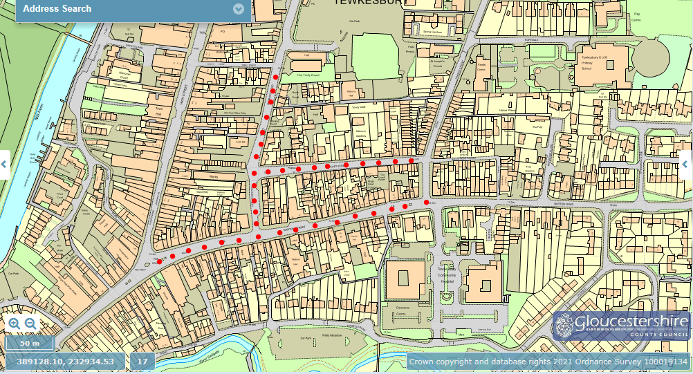
Approx. Road Closure extent indicated by Red dotted areas.
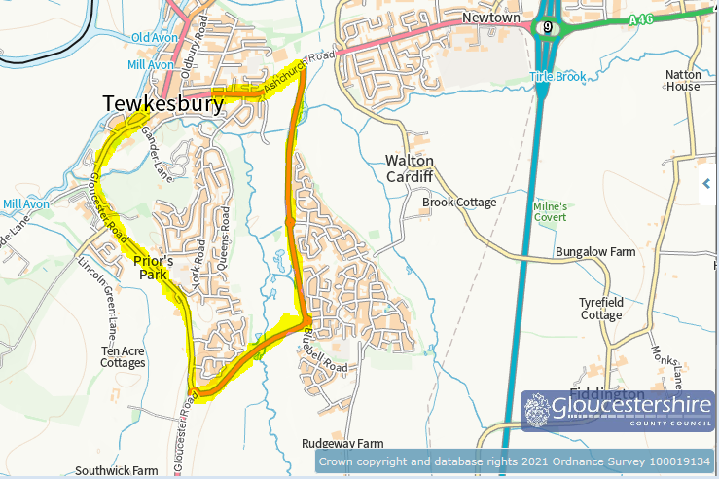
Diversion route highlighted yellow.

