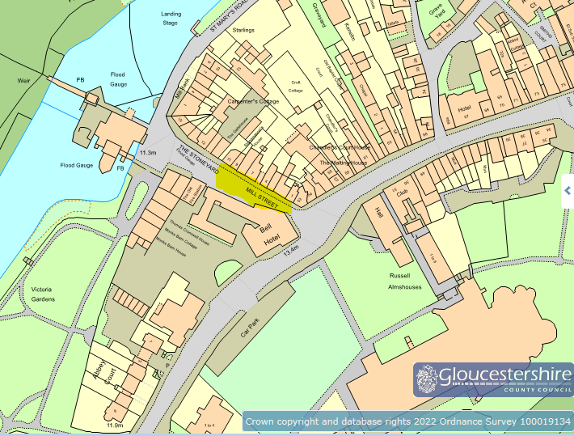
ROAD CLOSURE EXTENT – HIGHLIGHTED YELLOW AREA

