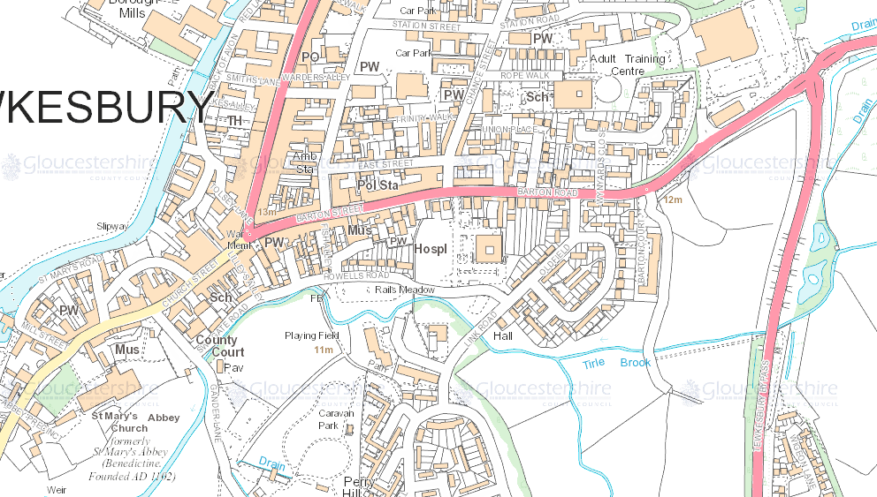
Road closed in Easterley Direction
Traffic Flow Westerley Direction

